SmartCare v0.3 - Domain Model Workbook
Week 6 student resource

Requirement-to-Concept Trace

Requirement | Concept | State / behaviour | Decision
FR-01: Register new patients and store details | Patient | State: name, contact, address; Behaviour: register(), updateDetails() | Included as a core entity
FR-04: Manage healthcare practitioner details | Practitioner | State: name, specialty, id; Behaviour: viewSchedule(), updateProfile() | Included to track GPs
FR-05: Visibility of practitioner availability | Schedule | State: availableSlots, workingHours; Behaviour: checkAvailability() | Included to prevent booking conflicts
FR-06: Book appointments and prevent duplicates | Appointment | State: dateTime, status; Behaviour: createBooking(), cancel() | Included as a core transaction
FR-09: Maintain reliable appointment history | AppointmentHistory | State: pastAppointments, records; Behaviour: fetchHistory() | Included for patient and clinic logs
FR-11: Generate basic operational reports | ReportManager | State: reportType, dateRange; Behaviour: generateSummary() | Included for clinic management

CRC Cards

Patient
Responsibilities | Collaborators
Store and update personal information | Appointment
Maintain own contact and medical history details | Appointment History

Practitioner
Responsibilities | Collaborators
Manage personal availability and working hours | Schedule
View assigned patient appointments | Appointment

Appointment
Responsibilities | Collaborators
Track date, time, and current status | Patient, Practitioner
Handle booking, rescheduling, and cancellation | Schedule

Optional class
Responsibilities | Collaborators
Aggregate daily/weekly appointment data | Appointment
Generate basic operational reports for management | Management

UML Class Diagram
Insert/draw UML here. Include defensible relationships and multiplicities.
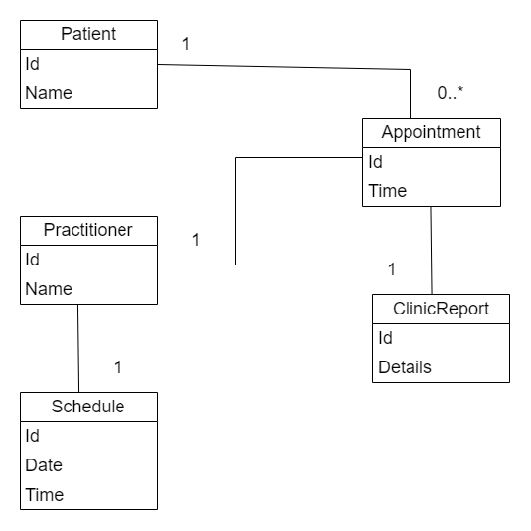
Fig: UML class diagram

Design Rationale
Explain class selection, responsibility allocation and key relationships.
Ans:
The domain model focuses on the core entities required for a small community clinic, avoiding complex enterprise hospital structures. Patient and Practitioner are primary actors, connected through the central Appointment class to handle bookings and avoid duplicates. Schedule manages availability to solve the problem of limited visibility, while ClinicReport supports basic operational reporting requested by management.

AI Design Review Record

AI suggestion | Evidence | Decision | Reason | Model change
Add a global InsurancePolicy class | No | Reject | Not requested by client and out of scope | None
Include Appointment class linking Patient and Practitioner | Yes | Accept | Directly solves booking management needs | Added Appointment entity
Implement real-time WebSockets for notifications | No | Reject | Too complex for a simple community clinic system | None
Add Schedule class for practitioner availability | Yes | Accept | Resolves limited visibility of practitioner availability | Added Schedule association
Include a ReportManager for operational summaries | Yes | Accept | Directly supports basic operational reporting | Added ClinicReport class

